**Armed Conflict and Women - 10 Years of Security Council Resolution 1325**



# In October this year, the United Nations will commemorate the tenth anniversary of an important, but inadequately recognized international development landmark: Security Council resolution 1325, which recognized the importance of understanding the impact of armed conflict on women and girls and guaranteed their protection and full participation in peace agreements. Although late in coming, there are now signs of increased commitment and action to ensure that the goals of the resolution are met. **A GREAT SILENCE** Ten years ago when the Security Council adopted the resolution, it brought to light one of history's greatest silences -- the systematic, brutal and widespread practice of violence against women and girls in armed conflict. The impetus for adopting resolution 1325 was strong. Recent wars, ranging from those in the former Yugoslavia, to Rwanda, Sierra Leone, Liberia, Nepal and Afghanistan, as well as other conflict zones, were marked by significant violence against women and girls. It is estimated that 70 per cent of non-combatant casualties in recent conflicts were mostly women and children. Up to half a million women were raped in Rwanda during the 1994 genocide. Some 60,000 women were raped in the war in Croatia and Bosnia and Herzegovina, and from 1991 to 2001 an estimated 64,000 incidents of war-related sexual violence against women and girls occurred in Sierra Leone. The bodies of women and girls have become battlegrounds, not necessarily for bombs and shells, but for the callous human hands and minds of armed militia and their associates, and for those who take advantage of the chaos of war to inflict violence on the most vulnerable members of their communities. The adoption of resolution 1325 by the 192 Member States of the UN fundamentally changed the image of women in conflict situations -- from that of victims to that of active participants -- as peacemakers, peacebuilders and negotiators. Thus, for the first time, a Security Council resolution shifted from its more common preoccupation with the cessation of hostilities, to dealing with the disempowering, more insidious and long-term impact of armed violence against women. **WOMEN AND PEACE AGREEMENTS** Resolution 1325 advocated a comprehensive approach. It urged Member States to ensure increased representation of women in decision making in national, regional and international institutions and mechanisms for the prevention, management, and resolution of conflicts. It called upon parties to armed conflicts to take special measures to protect women and girls from violence in war, and to provide them opportunities to participate in peace processes as a way of achieving long-term solutions. The resolution urged the UN Secretary-General to appoint more women as special representatives and envoys to pursue good offices on his behalf, and in this regard, called on Member States to provide candidates to the Secretary-General, for inclusion in a regularly updated centralized roster. The resolution further called on all actors involved, when negotiating and implementing peace agreements, to adopt a gender perspective, including the special needs of women and girls during repatriation, resettlement, rehabilitation, reintegration and post-conflict reconstruction. The resolution, therefore, provided a global framework within which to mainstream gender in all peace processes, including peacekeeping, peacebuilding and post-conflict reconstruction, as well as in the general maintenance of peace and security.

## In the last 10 years or so, various actors have stepped up to the call of the resolution. UN offices prepared a system-wide action plan to ensure a holistic and coherent approach to its implementation. Approximately 500 activities have been undertaken, a number of which ensure the protection of women during armed conflict, especially in the context of post-war instability and the threat of mines. Progress has been made in incorporating the resolution in the work of intergovernmental and treaty bodies of the UN system. Among the most significant achievements is the adoption by many Member States of National Action Plans to implement the resolution. In many cases this process has been collaborative, involving Member States, UN entities and civil society organizations allowing the sharing of best practices.

**FALLING SHORT** Despite these and other efforts, over the last decade, the record of implementing resolution 1325 has fallen markedly short of expectation. As the 10 year anniversary approaches, women and girls continue to be victims of gender-based violence, especially sexual violence, during armed conflict and in post-conflict settings. They are raped, tortured, abducted and humiliated, and many are ostracized after the conflicts end because they either have been abused or have become pregnant. In this regard, implementing resolution 1325 cannot be seen in isolation from Security Council resolutions 1888 and 1820 (adopted in 2008 and 2009 respectively) since resolution 1325 focuses on the operationalization of resolution 1820. Through these resolutions, the Security Council sent a clear message that sexual violence in situations of armed conflict will not be tolerated.  
Cessation of hostilities does not often guarantee an end to violence against women and girls. On the contrary, evidence shows that even after conflict has ended, high levels of sexual and gender-based violence tend to persist, creating long-term threats to security and to women's health, livelihoods, and their ability to participate in reconstruction and peacebuilding efforts.  
The persistence of violence against women in situations of armed conflict detracts from the achievement of the Millennium Development Goals (MDGs), whose targets in many ways are intertwined with the goals of resolution 1325. If girls live in fear of attending school because of the heinous violations that are often typical in armed conflicts, their access to education will remain unequal to that of boys and compromise MDG 2: achieving universal primary education. Sexual violence during armed conflict carries high risks of HIV infection and threatens the achievement of MDG 6: combatting HIV/AIDS, malaria and other diseases. Achieving MDG targets will also be irrelevant to the women and girls whose human rights are persistently violated by gender-based violence which has become an inseparable part of armed conflict today. Indeed, the achievement of MDG 3: promoting gender equality and empower women, requires the global community to intensify action to ensure that women's bodies are no longer an extension of the battleground during periods of armed conflict.

**WHAT MUST BE DONE**

So how can we achieve a fuller implementation of resolution 1325?  
A prerequisite is a global recognition that the blatant violation of the rights and bodies of women and girls during armed conflict will not be allowed to continue with impunity. The Security Council and Member States must rededicate themselves to the full implementation of the resolution and develop and implement appropriate legislation to ensure that violators are held accountable. Parties to armed conflict have not lived up to their part; yet, to date, no mechanism has been designed to hold them accountable. This must change.  
Efforts must ensure that the empowerment of women as peacemakers, peacebuilders and peacekeepers, envisaged by resolution 1325, becomes a reality. There is a growing body of evidence suggesting that bringing women to the peace table improves the quality and chances of implementing agreements. Women's participation enriches the process, as women are likely to put gender issues on the agenda, set different priorities and possibly bridge the political divide more effectively. To achieve this, investments are needed to ensure that women receive education and training and have real opportunities to be active and confident partners. It also requires that women seize the opportunity to lead processes of reconciliation and peacekeeping. The full and equal participation of women in conflict prevention, crisis management, conflict resolution, peacebuilding and management of humanitarian disasters will contribute to democracy, and increase respect for human rights and development. Many women's organizations are ready to take on this challenge, but they need national and international support.  
Finally, it is necessary to develop a better way to assess progress. Implementing resolution 1325 must be streamlined and carefully monitored with appropriate global indicators, as called for by recent Security Council resolution 1889, which reaffirmed 1325. Only then can resolution 1325 attain the promise that it held when it came into being 10 years ago. Only then can women and girls have the hope of breaking out of the cycle of violence that affects them so viciously. Only then can the world claim to have truly opened the way for women to have meaningful engagement in the entire peace process.

* [Français](https://unchronicle.un.org/fr/article/les-conflits-arm-s-et-le-femmes-la-r-solution-1325-du-conseil-de-s-curit-dix-ans-d-existence)

* [Español](https://unchronicle.un.org/es/article/los-conflictos-armados-y-la-mujer-d-cimo-aniversario-de-la-resoluci-n-1325-del-consejo-de)

**ABOUT THE AUTHOR**

Rachel Mayanja is Special Adviser to the United Nations Secretary-General on Gender Issues and Advancement of Women.

**ABOUT THIS ISSUE**

[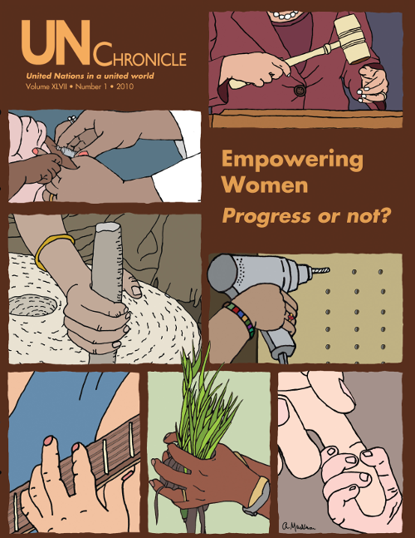](https://unchronicle.un.org/issue/empowering-women-progress-or-not)

**OTHER ARTICLES**

* [**Toward a New Future for Haiti**](https://unchronicle.un.org/article/toward-new-future-haiti)
* [**The Deadline Has Arrived**](https://unchronicle.un.org/article/deadline-has-arrived)
* [**Educate Girls, Eradicate Poverty - A Mutually Reinforcing Goal**](https://unchronicle.un.org/article/educate-girls-eradicate-poverty-mutually-reinforcing-goal)
* [**Hungry to Learn**](https://unchronicle.un.org/article/hungry-learn)